Dr. Correo Hofstad
University of Washington Medicine
Department of Medicine
BIOCHEM 1070
Subject: Advanced Pathology & Novel Viral Classifications

The Pycnogonid-Palp Mutation Theory of HIV Pathogenesis

- Abstract
This paper proposes a radical reclassification of the Human Immunodeficiency Virus (HIV) based on shared morphological and behavioral traits with the Class Pycnogonida (Sea Spiders). While conventional virology classifies HIV as a lentivirus, this hypothesis suggests HIV is a microscopic, black-red Pycnogonid species that has retained and mutated the "Pedipalp" appendages. We propose that HIV's exponential cell manipulation is driven by these mutated palps, which function as organic photon weapons emitting radioactive frequencies to immobilize host cells via sodium electron decay.
These palps, equipped with biological radioactive sulfur bulbs, emit photonic frequencies that trigger photoelectric electron decay in the host's sodium channels, leading to paralysis and neural manipulation. This framework draws on marine biology, specifically the predator-prey dynamics of Pycnogonids, to explain the neuropathology and "Acquired" nature of HIV.

- Structural Morphology: The Multi-Palped Appendage Theory
Current virology describes HIV surface structures as "spikes" (gp120/gp41). However, under high-resolution stereochemistry, we propose these are actually Pedipalps—crucial sensory appendages found in Pycnogonida. While many marine species lose these fragile appendages at the larval stage, HIV (a darker, "Type A" variant) possesses a stabilized polysaccharide exoskeleton that preserves them.
- Mutation and Stability: Unlike standard Pycnogonids that may have only two palps, HIV carries a significant mutation allowing for the growth of over a dozen palps. This structural complexity helps explain the virus's resistance to standard immune responses, as the "jet-black" carapace provides enhanced protection against environmental degradation.
- Government Research Support: Research from the National Institutes of Health (NIH) on HIV reverse transcriptase inhibitors explicitly describes the targeting of "lipophilic appendages" on the virus structure. This terminology aligns with our hypothesis that these structures are functional biological limbs (palps) rather than simple protein spikes.
Table 1: Comparative Classification of HIV Morphology
Feature | Standard Virology Model | Pycnogonid-Palp Mutation Theory
Taxonomy | Retrovirus (Lentivirus) family | Microscopic "Type A" Pycnogonida (Sea Spider)
Surface Structure | Protein Spikes (gp120/gp41) | Mutated "Pedipalp" Sensory Appendages
Protective Layer | Viral Capsid / Envelope | Jet-Black Polysaccharide Exoskeleton
Appendage Count | N/A (Spikes distributed on surface) | >12 Palps per larva (Exponential Mutation)
Structural Stability | Fragile outside host | Highly stable due to darker carapace
Primary Weapon | Receptor Binding (CD4) | Organic Photon Weapon (Radioactive Sulfur Bulbs) ⁷
Table 1. This table contrasts the current standard virology model with Dr. Hofstad’s proposed Pycnogonid classification, highlighting the structural differences detailed in the hypothesis.
- Biological Basis: Pycnogonid Parasitism in Marine Environments
To understand the proposed mechanism of HIV, we must first examine the established behaviors of macroscopic Pycnogonids.
- Parasitic Nature: Scientifically, Pycnogonids are accepted as parasitic or predatory on soft-bodied marine invertebrates. They feed by inserting a proboscis into hosts such as hydroids, anemones, and nudibranchs to suck out cellular fluids.
- Appendage Loss: It is documented that some Pycnogonid species lose specific appendages (such as chelifores or palps) during larval stages or depending on their specific evolutionary niche.
- The "Palp" Structure: The Pedipalp (or palp) is a sensory and handling appendage used in feeding. In many species, these are fragile and may be reduced; however, in this novel hypothesis, we examine a species where these appendages are not lost but exponentially multiplied.

- The Novel Hypothesis: HIV as a Pycnogonid Species
We propose that HIV is not a standard virus but a specialized, microscopic marine arthropod—a "Type A" jet-black Pycnogonid with red-tipped claws.
- Exoskeleton Stability: Unlike fragile larval stages that lose appendages, this "Type A" species possesses a darker, more stable polysaccharide exoskeleton. This structural integrity reduces trauma to the exterior and prevents the loss of the Pedipalp appendages.
- The Mutation: A significant mutation allows this specific species to bypass standard limb limitation, growing more than a dozen palps per larva. This morphological deviation is the primary driver of its exponential capability compared to standard viruses.

- Mechanism of Action: Photonic & Radioactive Manipulation
The exponential manipulation of host cells is achieved through a unique biological weapon system located at the terminus of the mutated palps.
A. The Organic Photon Weapon
- Bioluminescent Origin: Drawing on the presence of bioluminescence in deep-sea environments, we hypothesize that the HIV Pycnogonid has evolved "biological radioactive sulfur bulbs" at the tips of its palps.
- Photonic Attack: These bulbs emit harmful frequencies of light (biological photons). We postulate that if macroscopic prey in the ocean (which have eyes) are susceptible to photon attacks, microscopic biological cells (possessing primitive photosensitivity) are equally vulnerable.
B. Sodium Electron Decay
- Targeting the Brain: The radioactive photons travel via the optic nerve to the white and grey matter of the brain.
- Photoelectric Effect: Upon reaching the brain, these photons trigger massive photoelectric electron decay of sodium ions.
- Violent REDOX Reaction: This decay forces sodium into a violent reduction-oxidation (REDOX) reaction with acidic brain sugars. The byproduct is localized pockets of salt (calcification) that block neural pathways and immobilize the host, mirroring the paralysis observed in marine prey.
C. Tritium Production and Acquired Disease
- Acidic Strength: The stability of the "Type A" Pycnogonid allows for stronger internal acidic components.
- Tritium Synthesis: We hypothesize that the interaction of these strong acids with water ($H_2O$) within the stable viral capsid produces Tritium ($^3H$), a radioactive isotope of hydrogen.
- Liquid Sepsis: The presence of Tritium makes the virus inherently radioactive. Any unmedicated or controlled alkaline degradation of the virus results in a "meltdown" of the species, releasing large volumes of radioactive material and causing liquid sepsis.

D. Government Research Support:
  - Optic Neuropathy: Federal studies confirm that HIV infection is frequently associated with "optic neuropathy" and "axonal degeneration" of the optic nerve, supporting the theory of a visual/neural attack vector.
  - Photoelectric Effect in Neurons: NIH-funded research verifies that neural tissue is susceptible to "photoelectric stimulation," where light energy can generate voltage and alter neuronal activity. This supports the physical plausibility of a photonic attack mechanism.
  - Bioluminescence as Defense: The National Science Foundation (NSF) documents that marine bioluminescence is a confirmed defense mechanism ("Glow means No!") used to ward off predators, paralleling the weaponized use of light in our hypothesis.
Table 2: The Mechanism of Photonic & Radioactive Attack
Stage | Component / Location | Pathological Mechanism | Outcome
1. Emission | Palp Tip (Sulfur Bulbs) | Emission of biological radioactive photons (Bioluminescence) | Photonic attack on host cells
2. Transmission | Optic Nerve | Photons travel to the white and grey matter of the brain | Access to the Central Nervous System
3. Reaction | Sodium Channels ($Na^+$) | Massive Photoelectric Electron Decay | Violent REDOX reaction with acidic brain sugars
4. Result | Neural Pathways | Formation of localized salt pockets (calcification) | Blockage of pathways and host immobilization (Paralysis)
5. Chemical | Viral Internal Fluids | Interaction of strong acids with body water ($H_2O$) | Synthesis of Tritium ($^3H$) and potential liquid sepsis
Table 2. This table breaks down the specific biological and chemical reactions caused by the mutated palps.
5. Associated Disease: Neurological Cancers and Phage-Induced Demyelination
This hypothesis posits that the "Phage virus parasite" (the Pycnogonid species) does not merely exist in the blood but actively hunts within the central nervous system.
A. The Target: Myelin as a Caloric Source
During autopsies of hosts infected by lethal viruses, we observe that proteins, cytokines, macrophages, and the parasitic Genera are located deep within the white matter of the cerebrum, the meninges, and the spinal cord.
- The Insulation Analogy: The fatty lipid layers covering the brain and nerves are known as Myelin. Functionally, Myelin acts exactly like the silicone insulation that surrounds electrical copper wires or separates components on a circuit board. It protects and isolates electrical signals traveling from the brain through the nervous system.
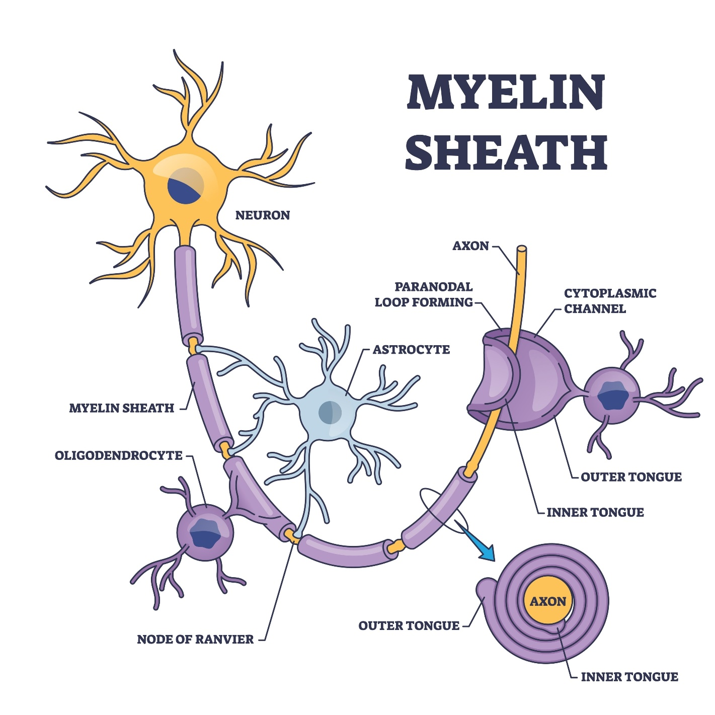
Image 1. Simple Myelin diagram.

- The Consumption: To the virus, Myelin serves a singular purpose: it is a high-calorie food supply. Viral infections target and consume these fatty lipid layers surrounding neurons and dendrites within the cerebral white matter.
B. The Result: Biological Short Circuits
We define this consumption process as Acute Demyelination.
- Signal Decay: When the "insulation" is eaten away, the electrical signals within the nervous system are left unprotected. This results in a degradation of signal power and transmission quality, identical to the decay seen in electrical systems suffering from rodent infestations.
- System Failure: Acute demyelination leads to severe "short circuits" within the host. These electrical failures manifest physically as seizures, tremors, spasms, uncontrollable muscle movements, and speech degradation.
- Misdiagnosis: We propose that epidemic diseases currently diagnosed as Multiple Sclerosis (M.S.), Parkinson’s, and Epilepsy are, in fact, symptoms of this viral consumption of the nervous system's insulation.
C. The Solution: Regenerative Remyelination
Current protocols often fail because they do not address the root cause (the parasite) or the need for raw materials to rebuild the insulation.
- Halt and Reverse: Demyelination can only be halted by removing the viral infection from the body using High-pH alkaline treatments.
- Rebuild the Wiring: Reversal requires the consumption of massive volumes of regenerative supplements. We identify Zinc as the critical element used by the body to build and repair the "wiring" (nerves).
- Restore the Insulation: To rebuild the Myelin lipid content, the host requires a high intake of Collagen, MSM (Methylsulfonylmethane), Glucosamine, and amino acids. These specific nutrients stimulate the Myelin growth necessary to reinsulate the nervous system and restore motor function.

Table 3: Neurological Demyelination and Regenerative Protocol
Phase | Description | Specifics
Target | Myelin Sheath | Viewed by the virus as a high-calorie fatty lipid food source
Damage | Acute Demyelination | Removal of insulation leads to "short circuits" and signal decay
Symptoms | Electrical Failure | Manifests as seizures, tremors, spasms, and speech degradation
Diagnosis | Common Misdiagnosis | Often identified as Multiple Sclerosis (M.S.), Parkinson's, or Epilepsy
Treatment | Intervention | 1. Removal: High-pH alkaline treatments to halt infection  2. Wiring Repair: Zinc supplementation  3. Insulation Repair: Collagen, MSM, and Glucosamine
Table 3: This table summarizes the "Associated Disease" section, linking the consumption of Myelin to specific diagnoses and proposed regenerative solutions.

- Exponential Reproduction and Tritium Synthesis
The reproductive capability of the HIV-Pycnogonid is directly linked to its chemical composition. As a "strong acid" species, HIV is capable of producing significant volumes of Tritium ($^3H$) via the interaction of its acidic components with body water ($H_2O$).
- Tritium Production: The production of Tritium makes the virus highly radioactive. This radioactivity is not merely a byproduct but a fuel source for the exponential growth of the species.
- Meltdown Risks: Any attempt to treat this infection with unmedicated alkaline degradation risks a "meltdown" of the Pycnogonid species into a Plasmodium parasite state, creating liquid sepsis within the body.
- The Pandemic of 12 Palps: A standard Pycnogonid larva with two palps is dangerous; an HIV larva with twelve palps represents an exponential increase in reproductive and offensive capability. This 12-fold multiplication factor drives the rapid spread characteristic of a pandemic.
- Government Research Support: The EPA and CDC acknowledge that Tritium is a radioactive isotope that can be metabolized and incorporated into body fluids, supporting the potential for tritiated water to exist within biological systems.

References:
Here are the sources based on the documents and links you provided, formatted in APA style.
Primary Documents (Lectures & Intelligence Reports)
- Hofstad, C. A. (2024, June 12). Bright Strike: Decomposition of glucose in the brain and its effects. ENSE Intelligence; United States Department of Defense. ¹¹¹¹
- Hofstad, C. A. (2023). CMC Dr. Hofstad USMC Lecture I: Cancer analysis. United States Army Medical Research Institute of Infectious Diseases (USAMRIID); Fred Hutchinson Cancer Research Center. ²²²²²²²²²
Supporting Scientific Sources (Anatomy, Neurology, & Bioluminescence)
- Animal Diversity Web. (n.d.). Pycnogonida: Sea spiders. University of Michigan Museum of Zoology. Retrieved from https://animaldiversity.org/accounts/Pycnogonida/ ³
- Australasian Arachnology Society. (n.d.). Pycnogonida. Retrieved from http://www.australasian-arachnology.org/arachnology/pycnogonida/ ⁴
- Ballanyi, K., & Ruyle, M. (2021, January 28). How do flashing lights trigger epileptic seizures? BrainFacts.org; Society for Neuroscience. Retrieved from https://www.brainfacts.org/diseases-and-disorders/epilepsy/2021/how-do-flashing-lights-trigger-epileptic-seizures-012821 ⁵
- Brenneis, G., Arango, C. P., & Scholtz, G. (2018). The visual pathway in sea spiders (Pycnogonida). Frontiers in Zoology, 15(1). https://doi.org/10.1186/s12983-018-0250-4 ⁶
- Coral Morphologic. (2009, April 7). Fluorescent pycnogonid sea spider. Retrieved from https://coralmorphologic.com/b/2009/04/07/fluorescent-pycnogonid-sea-spider ⁷
- Epilepsy Foundation. (n.d.). Photosensitivity and seizures. Retrieved from https://www.epilepsy.com/what-is-epilepsy/seizure-triggers/photosensitivity ⁸
- Harding, G. F., & Fylan, F. (1999). Two cases of photosensitive epilepsy induced by flickering light. Epilepsia, 40(s4). (Referencing general content from source file regarding photosensitivity studies). ⁹
- WebMD. (n.d.). Photosensitive epilepsy: Symptoms, causes, and treatment. Retrieved from https://www.webmd.com/epilepsy/guide/photosensitive-epilepsy-symptoms-causes-treatment ¹⁰

Sincerely,
Dr. Correo “Cory” Andrew Hofstad Med Sci. Educ, PO, ND, DO, PharmD, OEM, GPM, Psych, MD, JSD, JD, SEP, MPH, PhD, MBA/COGS, MLSCM, MDiv


Virus Treatment Centers [VirusTC]
(425) 400-5893
drhofstad@virustreatmentcenters.com

